Case Study

News International Scandal

WOMENS PARTICIPATION IN THE OLYMPIC GAMES
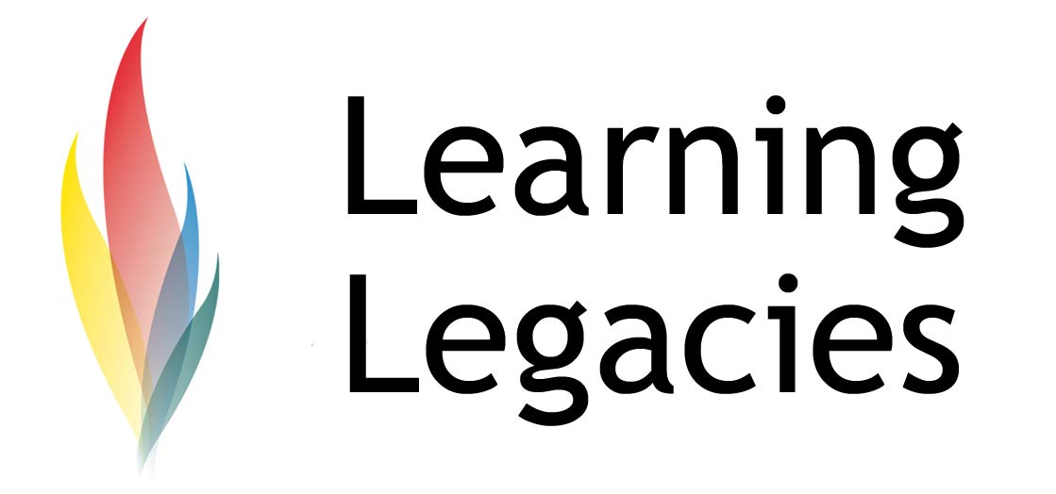

The Impact of the News International Scandal on the London 2012 Games

Private sponsorship deals are vital to the funding of a successful Olympic & Paralympic Games, to the continued support of the Olympic Movement itself, and to the realisation of legacy goals. Sponsorship of the Olympic Games is realised via establishing the role of a TOP Partner.

The Top Partner Programme is the official sponsorship programme of the Games, and allows sponsorship deals to be established at global or domestic level, over a period of years, within a particular classification (for example, Cadbury are the official Treat Provider of the Games) and particular rights attached (including the use of Olympic imagery and marks).

Media Rights Sales

Due to the sales of global media rights for the Games, and the global audience of billions that will watch the athletes compete, TOP Partner status is highly desirable. Companies stand to reach an immense audience to whom they can market their products and services, benefiting not only from media exposure, but also from the unique and positive association that only association with Olympic athletes, role models and sporting heroes can bring. TOP Partner revenue accounts for around 40% of the total revenues generated by the Games.

However, the lucrative practice of media rights sales has caused concerns to arise in terms of the impact of media coverage of a wide range of issues, including attracting controversy (for

example, following the Deepwater Horizon BP oil spill), the perceived legitimisation of regimes
that have, in the past, raised human rights concerns (e.g. China and the Beijing Olympics) and the recent News International scandal.

The Beijing Games 2008
A perceived benefit of hosting large scale sports events such as the Olympic Games is the concept of ‘nation building’; the idea that the global – and positive – media coverage associated with the event will raise national pride on the world stage, and develop a more positive global image of that nation. One might recall the historic image of Nelson Mandela presenting the Rugby World Cup Trophy to François Pienaar in 1995 – an iconic image reminiscent of the great gains made by a post-apartheid South Africa.
The Beijing Olympics were similarly viewed by the Chinese government as an opportunity to showcase the economic and political development of China, and to present an image of democracy, openness and societal harmony. However, some cynics have raised comparisons with the political theatre associated with the 1936 Olympics in Berlin and the 1938 FIFA World Cup in Italy. ‘Proponents of media freedom sought to leverage the well-entrenched Olympics norm of pervasive and unfettered media access and the PRC’s specific commitments to provide a freer-than-normal media environment for the Beijing Olympics,

pressing to extend the regime’s new tolerance to Chinese journalists and beyond the Games’.
Brady (2009) refers to the Beijing Games and associated media coverage – as a campaign of ‘mass distraction’, whereby the Chinese Government waged a propaganda campaign designed to mobilise the population around a common goal (the Olympic Games) in order to distract them from domestic issues of concern, such as inflation, unemployment & political corruption. Amnesty International further reported concerns that both international and domestic media coverage (websites and other news sources) were being blocked by the Chinese Government in a bid to block negative coverage, and as a means of using global media coverage as a propagandist tool.

News International

News International had previously established a partnership deal with the Olympic federation, whereby Rupert Murdoch’s portfolio of publications were to be afforded exclusive athletes
to British athletes ahead of the Games. This meant that News International had become an official partner of Team 2012, the Visa-backed project that supports potential British Olympians. At the
time of the deal, the now deposed News International Chief Executive Rebekah Brooks commented that: ‘This unique partnership gives our newspapers unrivalled access to the Team

Case Study

News International Scandal

WOMENS PARTICIPATION IN THE OLYMPIC GAMES
2012 athletes and means we will be able to throw our full support behind the team and give our readers the inside track.’

Clearly, the partnership was extremely valuable to News International, in addition to providing exposure and support for British athletes. In the immediate aftermath of the ‘phone hacking scandal, LOCOG and Team GB took immediate steps to publicly denounce and cut links with the news corporation, no doubt understanding the implications of retaining a relationship with such an unpopular organisation.

Such a partnership would have given News International newspapers – namely, The Sun, The Times and The Sunday Times – the right to carry the slogan ‘Official Newspaper of Team 2012’ with athletes such as Sir Chris Hoy and Rebecca Adlington engaging with the publications in interviews and stories. However, following the recent hacking scandal that led to the closure of the News of the World, and to a subsequent public inquiry.

Team 2012 subsequently backed out of the deal, commenting that; "as a result of the closure of News of the World the contract can no longer be fulfilled as originally envisaged...All parties in the joint venture are working to make sure that we continue to give the 1,200-plus athletes from Team 2012 Visa the best chance of achieving success ... at London 2012. To help drive national support for Team 2012, we are now exploring media partnerships across a range of channels."

Team 2012 were not the only partners to cancel their deals with News International – a range of other brands cancelled advertising agreements that they had held on a relatively longstanding basis with the company.

The decision to cancel the Olympic partnership was made in accordance with all Olympic stakeholders associated with the Games – namely, Team 2012, LOCOG (the London Organising Committee of the Olympic Games, chaired by Lord Sebastian Coe), the British Olympic Association (BOA), Paralympics GB and UK Sport, the government agency responsible for the allocation of public money to Olympic sport.

Team 2012

Team 2012 was conceived to assist in the contribution of financial resources to the public funding allocated to Olympic sport, with funding channelled via the Team 2012 initiative to both UK
Sport and the BOA. Team 2012 has been central in the generation of millions of pounds of funding for the Games.

Summary

Global media coverage of the Olympic Games and other large scale sports events carry great advantages – namely the raising of significant amounts of financing for the event and the sport(s) concerned. However, the dangers inherent in such wide scale coverage must also not be ignored – for example, the dangers of being associated with unpopular sponsors, or the ramifications of media coverage manipulation as a means of legitimising political regimes.

Case Study

News International Scandal

WOMENS PARTICIPATION IN THE OLYMPIC GAMES

Further Information
- Olympic Marketing Fact File: http://www.olympic.org/Documents/marketing_fact_file_en.pdf
- Broudehoux, A. (2009) Spectacular Beijing: The Conspicuous Construction of an Olympic Metropolis: http://isites.harvard.edu/fs/docs/icb.topic233886.files/February_19/Broudehoux_Spectacular.pdf
deLisle, J. (2009) After the Gold Rush: The Beijing Olympics and China’s Evolving International Roles: http://www.fpri.org/orbis/5302/delisle.aftergoldrush.pdf

Brady, A. (2009) The Beijing Olympics as a Campaign of Mass Distraction. The China Quarterly, Vol. 197: pp 1-24

Discussion
- Why did Team 2012 move so quickly in severing ties with News International?

Case Study

News International Scandal

WOMENS PARTICIPATION IN THE OLYMPIC GAMES
This resource was produced as part of the 2012 Learning Legacies Project managed by the HEA Hospitality, Leisure, Sport and Tourism Subject Centre at Oxford Brookes University and was released as an Open Educational Resource. The project was funded by HEFCE and part of the JISC/HE Academy UKOER programme. Except where otherwise noted above and below, this work is released under a Creative Commons Attribution only licence.

Exceptions to the Licence
The name of Oxford Brookes University and the Oxford Brookes University logo are the name and registered marks of Oxford Brookes University. To the fullest extent permitted by law Oxford Brookes University reserves all its rights in its name and marks, which may not be used except with its written permission. The JISC logo is licensed under the terms of the Creative Commons Attribution-Non-Commercial-No Derivative Works 2.0 UK: England & Wales Licence. All reproductions must comply with the terms of that licence.

The Higher Education Academy logo is owned by the Higher Education Academy Limited and may be freely distributed and copied for educational purposes only, provided that appropriate acknowledgement is given to the Higher Education Academy as the copyright holder and original publisher.

Reusing this work
To refer to or reuse parts of this work please include the copyright notice above including the serial number. The only exception is if you intend to only reuse a part of the work with its own specific copyright notice, in which case cite that.

If you create a new piece of work based on the original (at least in part), it will help other users to find your work if you modify and reuse this serial number. When you reuse this work, edit the serial number by choosing 3 letters to start (your initials or institutional code are good examples), change the date section (between the colons) to your creation date in ddmmyy format and retain the last 5 digits from the original serial number. Make the new serial number your copyright declaration or add it to an existing one, e.g. ‘abc:101011:011cs’.

If you create a new piece of work or do not wish to link a new work with any existing materials contained within, a new code should be created. Choose your own 3-letter code, add the creation date and search as below on Google with a plus sign at the start, e.g. ‘+tom:030504’. If nothing comes back citing this code then add a new 5-letter code of your choice to the end, e.g.; ‘:01lex’, and do a final search for the whole code. If the search returns a positive result, make up a new 5-letter code and try again. Add the new code your copyright declaration or add it to an existing one.

‘‘Olympics to Introduce New Media Relationship,’’ China Daily, December 22, 2006; Richard McGregor, ‘‘China Eases Rules on Media for Olympics,’’ Financial Times, December 2, 2006; China Asked to Extend Rights to its Own Media; Foreigners Granted More Press Freedom,’’ International Herald Tribune, October 20, 2008. Cited in De Lisle, 2009.

